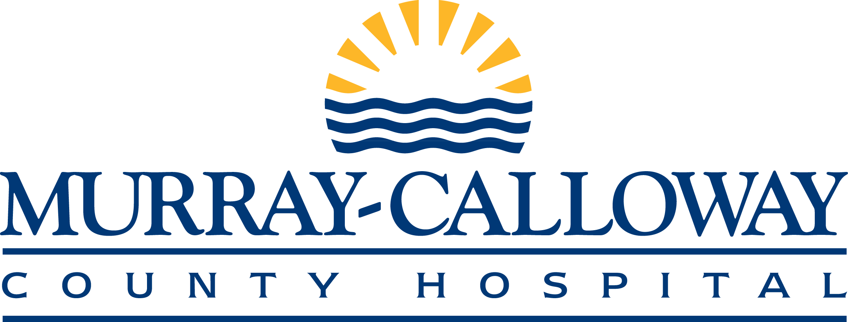
Financial Assistance Packet
This packet includes information required for the MCCH to determine if you are eligible for financial assistance for dates of service. Please complete the enclosed packet, sign all the forms and return to:
Attn: Financial Counselor, MCCH, North Tower, 270-752-2186
or by mail to 803 Poplar Street, Murray, KY 42071
Appendix:
- Financial Assistance Notification Letter
- Eligibility List
- Proof of Income list
- Zero Income Statement
- Financial Screening Sheet
- DSH Application and Medicaid/KCHIP Screening Form
- Financial Assistance Worksheet

MCCH Financial Assistance guidelines state that you have 10 DAYS to return all needed information or your application may be denied.
Thank you and if you have any questions please see the contact information below.
Vonnie S. Hays Adams
Director of Patient Access
vsadams@murrayhospital.org
270-762-1211

Appendix A
Financial Assistance Notification Letter

Date:
Patient Name:
Patient Address:
Patient Account #:
Date of Service:
Thank you for choosing Murray Calloway County Hospital. I am contacting you about a program we have that offers qualified households assistance with medical expenses. If you qualify, this program will assist you in resolving your outstanding balance with us.
If you are interested in applying for this assistance, please return the enclosed application with copies of all of the required information within 10 days. If you wish, you may also call and make an appointment with me to bring the information in to my office located on the first floor of the North Tower. My contact information is below. If I do not hear from you within the 10-day period, I will assume that you do not wish to apply and MCCH will continue with its collection efforts.
I appreciate your immediate attention to this matter.
Sincerely,

Financial Counselor
270-752-2186

Appendix B

Murray-Calloway County Hospital Financial Assistance Policy
Eligibility List

In order to be eligible for financial assistance:

- Applicants must be a citizen of the United States of America and have a Social Security Number. A student /employment visa issued social security number will not be accepted.

- Applicants must be a resident of Calloway County and/or employed in Calloway County. Full-Time/Part-Time Murray State University students who are not a permanent resident of Calloway County who have a temporary residence in Calloway County (which is not on-campus/university housing) may also apply. Applicants must be able to provide proof of residence and employment as applicable.

- Applicants must first be screened for or receive a denial from the Kentucky Medicaid of DSH Programs.

- The application for the Medicaid/DSH programs will also serve as the application for MCCH’s Financial Assistance Program.

- The application must be received by the MCCH Financial Assistance Counselor no later than 6 months (180 days) from the date of service or within three months from the last insurance payment.

- The debt in question must only be from MCCH or MCCH affiliates.

- Applicant cannot be covered by 3rd party payer.

Appendix C

Proofs of Income
Policy and Instructions

Proof of income is mandatory for all assistance programs. Acceptable forms must include the following:

- Copy of most recent tax statement or all W2’s for all members of the household.

- Copy of the year to date pay stub from all working age persons within the household.
AND/OR

Copy of unemployment check for all applicable household members.

AND/OR

Copy of workers compensation check for all applicable household members.

AND/OR

Copy of pension check for all applicable household members.

AND/OR

Copy of Social Security Income award statement of current benefit for all applicable household members.
AND/OR

Two notarized “Zero Income” statements completed by a non-relative.

- Two most recent bank statements: For all checking and savings Accounts as applicable for all applicable household members.

Appendix D
Zero Income Statement
To whom it may concern:
This is to certify that I, have zero income at this time. The last time I worked was and I made approximately per hour/week.

Signatures:____________________________________________________________________
Note: The witnesses must NOT reside in the patient’s residence and be non-relatives of the patient.
(Patient Signature) (Date)

(Witness Signature) (Date)
(Witness Address)
**Witness signature verifies that that the information above is complete and accurate to the best of their knowledge.
STATE OF KENTUCKY
COUNTY OF ________________________________
The foregoing document was acknowledged before me this _______________________ (date) by _______________________________ & ___________________________ (name of person(s) acknowledged).

__________________________
Notary Public
Printed Name: ___________________________
My Commission Expires; __________________________

Zero Income Statement 1

Appendix D
Zero Income Statement
To whom it may concern:
This is to certify that I, have zero income at this time. The last time I worked was and I made approximately per hour/week.

Signatures: ____________________________________________________________________
Note: The witnesses must NOT reside in the patient’s residence and be non-relatives of the patient.
(Patient Signature) (Date)

(Witness Signature) (Date)
(Witness Address)
**Witness signature verifies that that the information above is complete and accurate to the best of their knowledge.
STATE OF KENTUCKY
COUNTY OF ________________________________
The foregoing document was acknowledged before me this _______________________ (date) by _______________________________ & ___________________________ (name of person(s) acknowledged).

__________________________
Notary Public
Printed Name: ___________________________
My Commission Expires; __________________________

Zero Income Statement 2

Appendix E

Murray –Calloway County Hospital Financial Application
Financial Screening Sheet

Please complete and mail the information below, along with all of the required documentation listed in Appendix C & D if applicable, to: MCCH Financial Counseling Dept., 803 Poplar Street, Murray, KY 42071 or call, MCCH Financial Counselor at 762-1100 ext. 2186, Monday through Friday from 8:00 a.m. to 4:30 p.m. to set up a time to drop off the packet in person.

Patients cell/home phone number ;
Is the patient: Single Married (please circle one) If separated, how long? .
Are there minors in the home? Yes No (please circle one) If yes, how many? .
Are both the mother and father of the minor(s) living in the home? Yes No (please circle one)
Number of minor children in the patient’s custody .
Is the patient disabled? Yes No (please circle one)
Has the patient been deemed disables by a physician? Yes No (please circle one)
What is the nature of the disability? .
Has the patient applied for disability benefits from Social Security? Yes No (please circle one)
If so, what was the date the disability application was placed? .
Has the patient received any denials from the SSA? Yes No (please circle one)
If so, how many? .
Have you been before a judge to decide on your disability application? Yes No (please circle one)
What is the name and phone number of the attorney representing you on your disability case?
.

Have you applied for Medicaid? Yes No (please circle one) If so, when? .
Who is your case worker? . Phone # .

What is the total monthly household income?$_________ Annual Household Income $________
Is the patient unemployed? Yes No (please circle one) If so, how long? .
What is the total household income for the past 12 months? .
Is the patient unable to work for one month due to this illness or injury? Yes No (please circle one)
Appendix E – Page -2-

Is/was the patient the primary wage earner for the household? Yes No (please circle one)
Within the last 6 months, have you or your spouse carried insurance? Yes No (please circle one)
Does the patient have any health insurance that will cover this visit? Yes No (please circle one)
Name of the policy holder Company name .
Policy number Company phone number .
List the balance of any bank, 401k, or IRA accounts .
List year, make, model or all vehicles in the home: 1st ,
2nd , 3rd .
What is the amount owed on each of the vehicles? .
Do you have any stocks, bonds, motorcycles, boats, RV’s etc? .
What is the value of these items? .
Does the patient have life insurance? Yes No (please circle one) Term or Whole? .
If whole policy, what is the cash value? .

Is this visit due to a motor vehicle accident? Yes No (please circle one)
If yes, is there insurance involved? Yes No (please circle one)
(If yes, please complete the insurance information above)
Is the patient pregnant? Yes No (please circle one)
Was this visit due to a crime? Yes No (please circle one)
If yes, were you an innocent victim of a crime? Yes No (please circle one)
Will a police report be filed within 48 hours of the crime? Yes No (please circle one)

Patients employer name and number .
Spouse employer name and number .
Total amount of current unpaid medical bills .
Name and telephone number we have permission to speak with .
Contact relation to the patient .
Name of person completing this form (please print) .
Signature of the person completing this form .
Your relationship to the patient .

Appendix F

DSH Application and Medicaid/KCHIP Screening Form

Individual Information

Today’s Date: | Work Phone:
Patient’s Name: | Dates services were provided: / / - / /
Street Address: | Married/Single:
City: | Name of Spouse:
State: Zip Code: | Is the patient pregnant? Yes No (Circle one)
Social Security Number - - | Is the patient a resident of KY? Yes No Circle One)
Date of Birth: Birth sex:
Home Phone:

List the name, social security number, relationship and age of each person living in the household.
Household Members name | Social Security # | Relationship | Age

Does the individual have dependent children living in the home? Yes No (Circle one)
If the answer is YES, refer the individual to DCBS for Medicaid.
If the answer is NO, refer the individual to DCBS for Medicaid ONLY IF the individual has NOT received a denial from Medicaid within 30 days.
If the individual, who has no children less than 18 years of age, claims to be disabled, refer the individual to the Social Security Administration to apply for Supplemental Security Income.
Income Information
Patient Employer: | Social Security:
Spouse Employer: | Workers Comp:
Work Phone | SSI:
Total Gross Monthly Income: | Other:
Unemployment: | Total Family Unit Income:
Child Support:
Appendix F Page -2_

Insurance Information
Health/Life Insurance:
Phone Number:
Policy Number:
Group Number:
Policy Holder:
Relation to Patient:

Countable Resources
 | Bank Name | Balance Value
Checking
Savings
Money Market
Mutual Fund
Stocks
Bonds
Other
Total Health Bills Owed
Total Resources

Was the date of service related to an auto accident? Yes No (Circle one)
Have you applied for and been denied Medicaid or KCHIP Benefits? Yes No (Circle one)

Certifying Accuracy of Information

I hereby agree to furnish the Hospital all necessary information to allow them to determine my need to receive financial assistance for health care services received. I agree that the Hospital will be provided with or may obtain all documents necessary to verify my current income, employment status, and resources, and that failure to supply requested information within 10 working days is grounds for denial of my application for assistance. I also agree to notify the Hospital immediately of any change of address, telephone number, employment status or income.
I agree to allow the hospital representatives to determine eligibility and pursue state and assistance with Medicaid, KCHIP, and DSH.
I certify that the information provided on this application is correct to my knowledge and belief. I understand that if I give false information or withhold information in accepting assistance, I may be subject to prosecution for fraud. I understand that I have a right to request a fair hearing if I am dissatisfied with any action taken on my application. I understand that I must contact the hospital to make a hearing request.

.
Individual or Responsible Party Signature Date

. .
Hospital Employee Signature Date

Does the individual appear to qualify for Medicaid? Yes No (Circle one)
If yes, then refer the individual to the DCBS office in the county of the individual’s residence or
The individual should take a copy of this form with him/her to the DCBS office or to:

MedAssist Patient Account Rep
Murray Calloway County Hospital
803 Poplar St
Murray, KY 42071

Tel: 270-762-1891
Fax: 270-767-3662
Cell: 270-703-6110

Appendix G
Financial Assistance Worksheet

